Contents
Prerequisites 2
Adding Applications and M365 Apps 5
Adding 3rd party apps 5
Customizing M365 Apps 6
Drivers 6
Preparing the command line 6
Script parameters 6
Command Lines 9
Running the Script 10
Customizing the USB drive (optional) 12
Driver Support (optional but recommended) 12
Having DISM inject drivers on the fly (recommended if managing multiple models) 13
How to inject drivers into FFU 13
Device Naming (optional but recommended) 14
Prompt to enter name 14
Specifying Multiple Name Prefixes 15
Device Enrollment 16
Optional - Copy provisioning package to the USB drive 17
Optional - Using Autopilot for Existing Devices 18
Create User Driven Autopilot Profile 18
Install Azure AD, WindowsAutopilotIntune, Intune Graph Powershell modules 20
Get the User Driven Autopilot profile and convert to JSON 21
Multiple Autopilot Configuration Files 21
Optional - Copying a custom WinRE.wim 21
Optional – Adding Multiple Components using unattend.xml 23
Troubleshooting 23
Deployment 23
Creation 24

Prerequisites
- Enable Hyper-V – this can be done on either Windows 10/11 or Windows Server
Enable Hyper-V on Windows 10 | Microsoft Learn
Get started with Hyper-V on Windows Server | Microsoft Learn

- Install the latest Windows Insider Assessment and Deployment Kit (ADK) to the machine you installed Hyper V on.
You’ll need to do the following until Windows 23H2 is released
You’ll need to download and install the Insider Preview of the Windows ADK and the Windows PE add-on for the Windows ADK. This is due to a bug with optimizing ffu files which was fixed as of the 25295 version of the ADK. This will eventually roll up into the 23H2 version of the Windows ADK and ultimately in Windows 11 23H2.
https://www.microsoft.com/en-us/software-download/windowsinsiderpreviewADK
Install the Windows ADK first. When installing the Windows ADK, you only need the Deployment Tools feature checked. Take the defaults for the rest of the setup wizard.
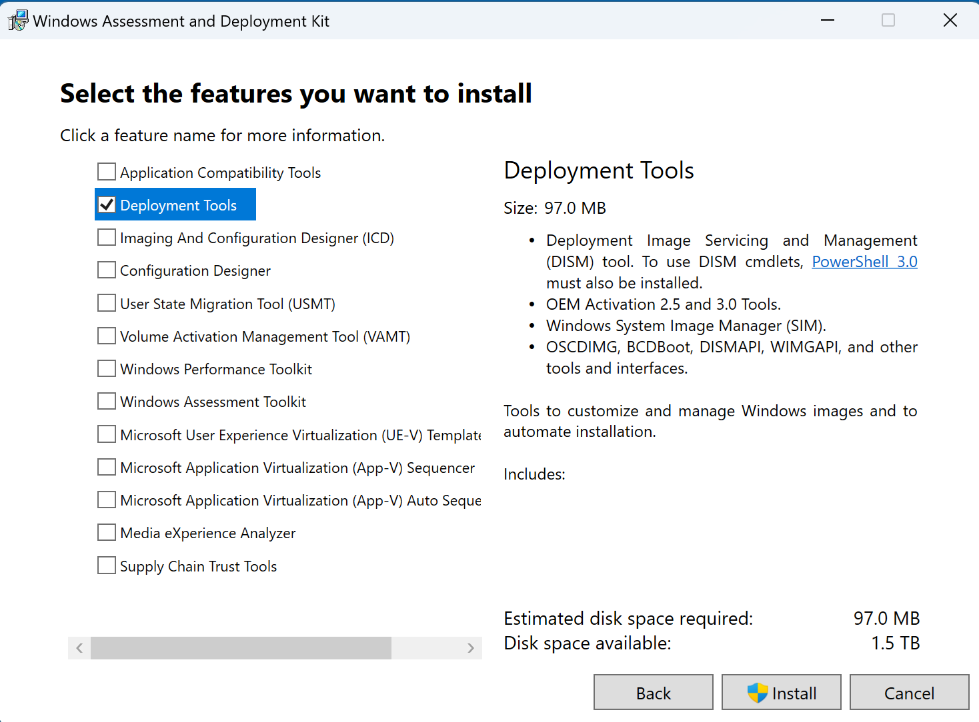
Install the WinPE add-on next. Install with default settings.
- If using a non-Windows Insider build, test/flight signing needs to be enabled for dism from the Insider ADK to run. You’ll end up with signing-related errors if you don’t enable test signing.
For test signing to be enabled on non-Windows Insider builds, Secure Boot needs to be disabled. You must do this first, otherwise you'll get an error message when trying to enable test signing via bcdedit.
Go to Start – search for Command Prompt – right click Command Prompt and select Run as Administrator
Run bcdedit /set testsigning on
Reboot the machine
After reboot, you should see a water mark on the desktop indicating Test Mode is enabled.
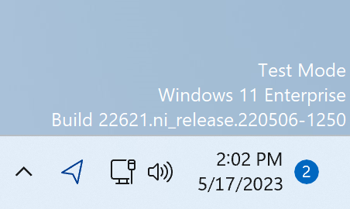
Note – For security reasons, it’s best to only enable test signing when necessary. This will only need to be done until the Windows 23H2 ADK is released or Windows 11 23H2 is released. Once that’s released, the dism fixes that are needed will be rolled up into the 23H2 public ADK and Windows 23H2 respectively. Once you’ve finished building your FFU, it’s best to turn off test signing and re-enable secure boot.
- If you're running a Windows Insider build, flight signing should be enabled. You can validate this by opening an admin command prompt and typing in bcdedit. You should see flightsigning as yes.
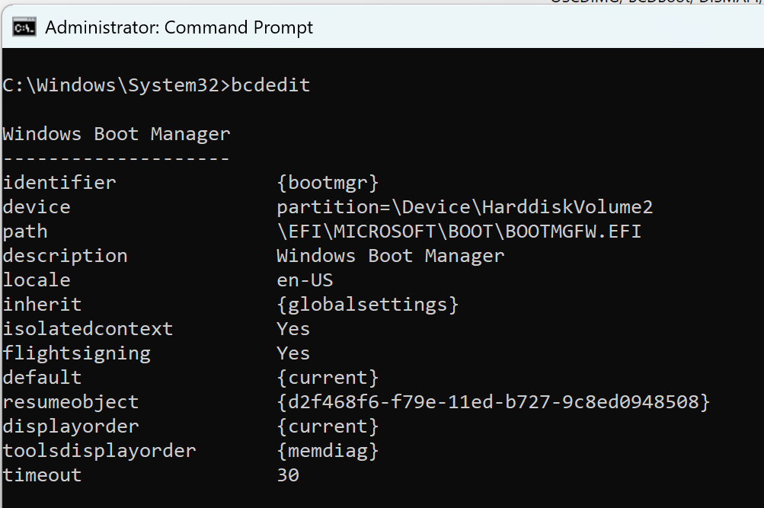
You'll still need to install the Windows Insider ADK, but you shouldn’t need to worry about flightsigning.

- Windows consumer media – download the Windows ISO from Visual Studio downloads, or the Windows Media Creation Tool. If you don’t have access to Visual Studio downloads, download the Windows Media Creation Tool from either of these links:
Windows Media Creation Tool for Windows 10
Windows Media Creation Tool for Windows 11
It’s recommended that you use consumer media, not business/Volume License. This is because Subscription Activation will fail if the media is mismatched from the key in the firmware. If you plan on using a MAK or KMS to activate, you can use media from VLSC, but if you expect the device to activate automatically and upgrade to Enterprise or Education SKUs via Subscription Activation, you must use consumer media.

- Extract the FFUDevelopment.zip file from the Github repo to C:\FFUDevelopment. If you must use another location, you’ll need to specify the -FFUDevelopmentPath parameter when running the PowerShell script to the new location (e.g. BuildFFUVM.ps1 -FFUDevelopment ‘D:\FFUDevelopment’)
The folder structure is as follows
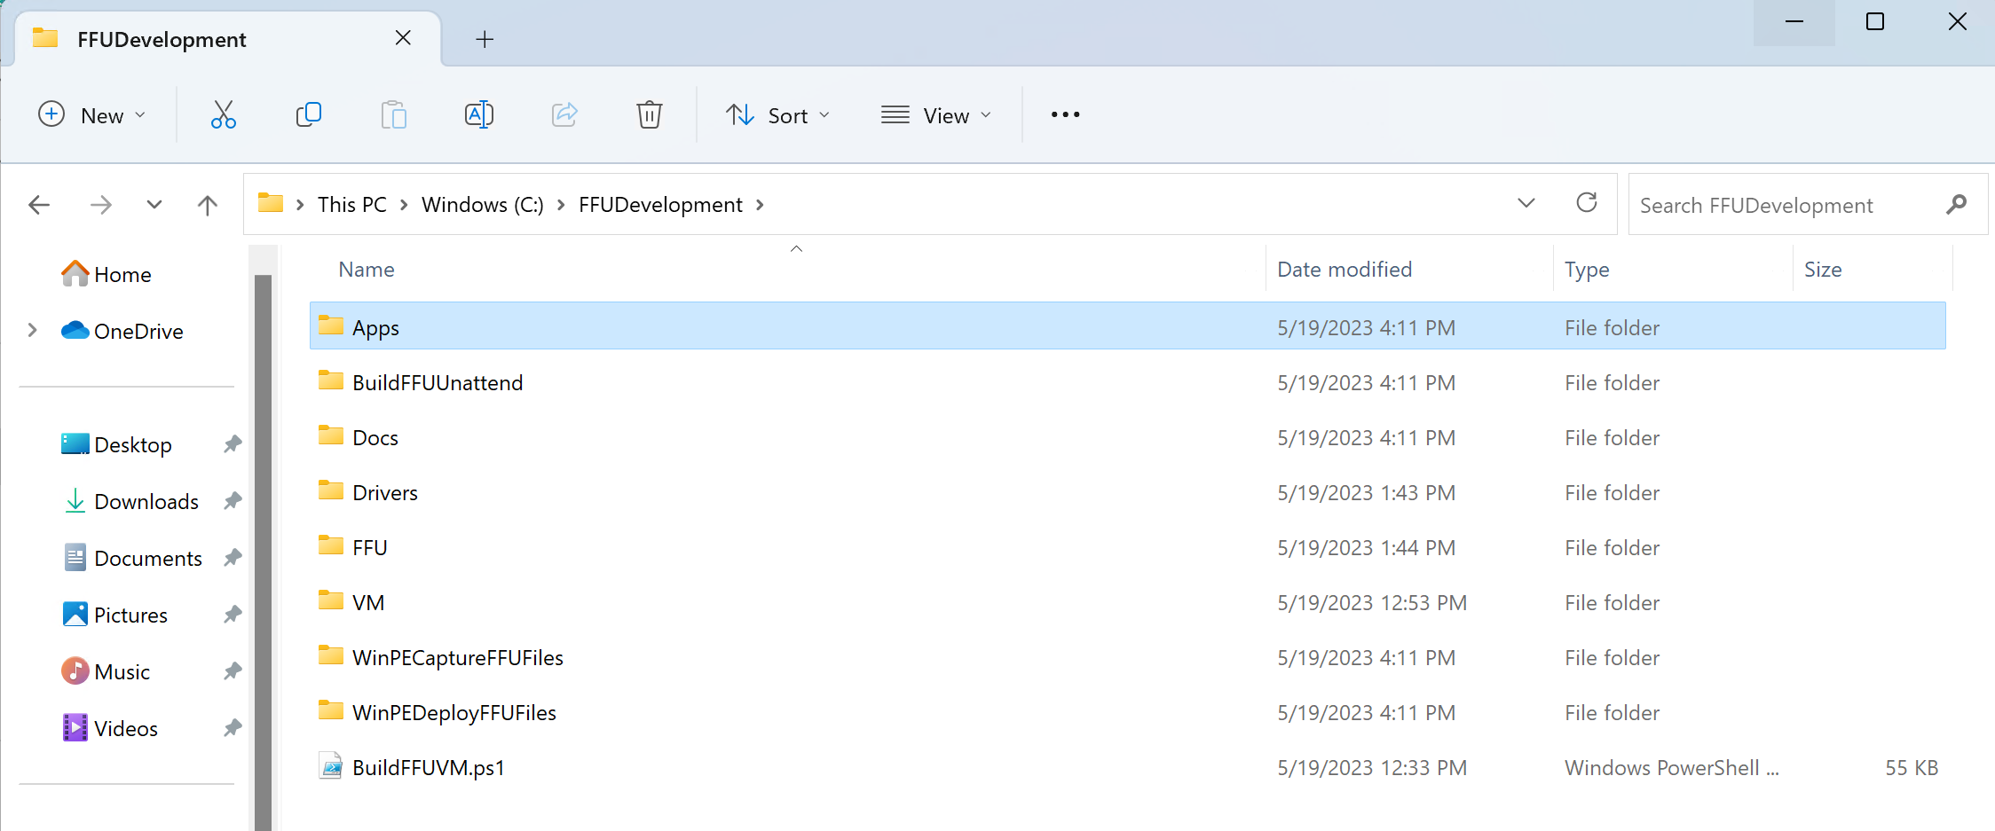

Adding Applications and M365 Apps
The FFUDevelopment\Apps folder contains the following files:
- Office folder
  - DeployFFU.xml
  - DownloadFFU.xml
- InstallAppsandSysprep.cmd
The Office folder contains a DeployFFU.xml and DownloadFFU.xml file that are used by the Office Deployment Toolkit to handle the download and deployment of Office.
The InstallAppsandSysprep.cmd file is a command file that will run during audit mode after Windows is installed to the VM which will run whatever commands are in that file.

Adding 3rd party apps
If you want to add additional applications to the FFU, create a new folder in the Apps folder and put the installation files in that folder.
For example, if you want to include Chrome, you would create a Chrome folder in c:\FFUDevelopment\Apps and copy in the GoogleChromeStandaloneEnterprise64.msi
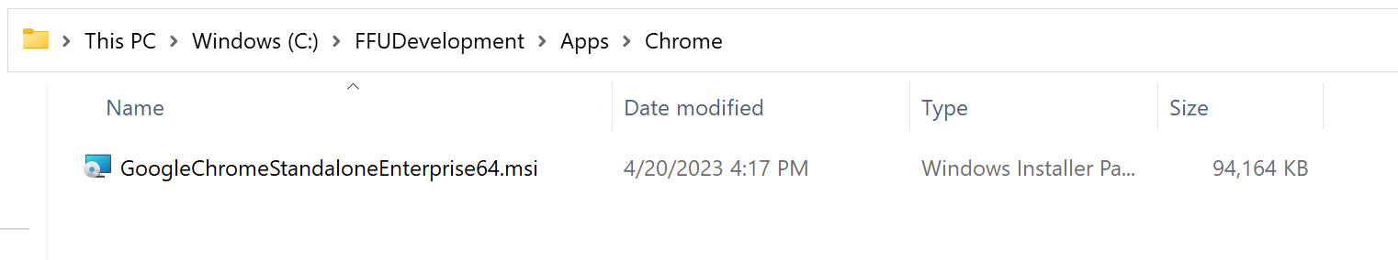
Next, modify the InstallAppsandSysprep.cmd file and include the silent command line to install Chrome. It’s recommended that for each app or command that you add to the file that you put a REM App Name (e.g. REM Google Chrome) on the line before the command so it’s easy for you to remember what each command is doing.
Do not remove the commands that delete the unattend.xml files or the sysprep related commands.
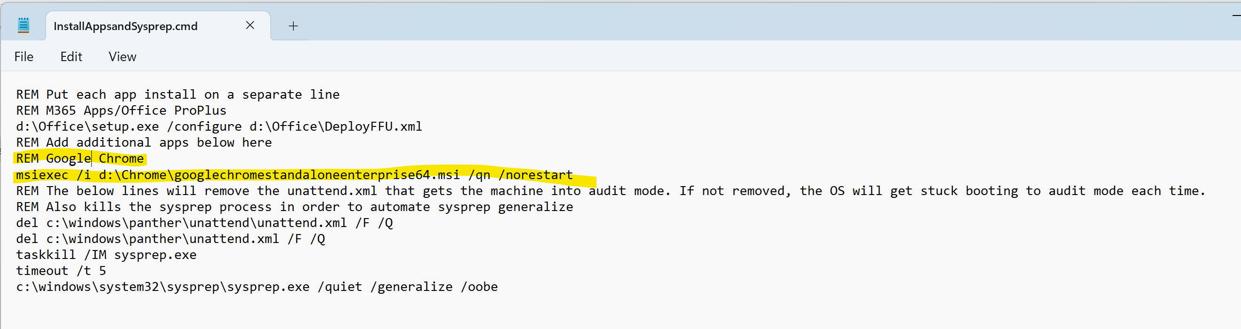

Customizing M365 Apps
If the -InstallOffice and -InstallApps parameters are both set to $true, the script will download M365 Apps/Office Deployment Toolkit and download M365 Apps to c:\FFUDevelopmentPath\Apps\Office.
It shouldn’t be necessary to modify the DownloadFFU.xml file in the Office folder.
If you want to modify which Office apps, client edition, channel, or any other properties, you’ll want to modify the DeployFFU.xml file.
The DeployFFU.xml file will install Word, Excel, and PowerPoint. Outlook is excluded. If you have an XML that you normally use for Office, it’s suggested to replace DeployFFU.xml. In other words, delete the existing DeployFFU.xml file, copy your XML file to the c:\FFUDevelopment\Apps\Office directory, and rename it to DeployFFU.xml.
If you want to change the name of the DeployFFU.xml file for whatever reason, you’ll also need to change the path in the InstallAppsandSysprep.cmd file as well as the BuildFFUVM.ps1 file.

Drivers
There is an empty folder named Drivers where you can add the drivers you want to include in the FFU. This is typically used if the FFU you are building is for a specific model (e.g. Surface Laptop Go 2). You wouldn’t want to include drivers for multiple models as that can bloat the drivers store and waste space on the device, and even cause plug and play matching to match older or unexpected drivers. If you have multiple models you want to use this FFU with, you can dynamically choose which drivers you want on the deployment USB drive by creating a drivers folder on the deployment USB drive and creating folders for each model and the associated drivers. For more information on how to modify the USB drive to handle drivers, see the Drivers support section.

Preparing the command line
The following table is a list of all parameters the script accepts.

Script parameters
Parameter | Type | Description
ISOPath | String | Path to the Windows 10/11 ISO file.
WindowsSKU | String | Edition of Windows 10/11 to be installed, e.g., 'Home', 'Home_N', 'Home_SL', 'EDU', 'EDU_N', 'Pro', 'Pro_N', 'Pro_EDU', 'Pro_Edu_N', 'Pro_WKS', 'Pro_WKS_N'
FFUDevelopmentPath | String | Path to the FFU development folder (default is C:\FFUDevelopment).
InstallApps | Bool | When set to $true, the script will create an Apps.iso file from the $FFUDevelopmentPath\Apps folder. It will also create a VM, mount the Apps.ISO, install the Apps, sysprep, and capture the VM. When set to $False, the FFU is created from a VHDX file. No VM is created.
InstallOffice | Bool | Install Microsoft Office if set to $true. The script will download the latest ODT and Office files in the $FFUDevelopmentPath\Apps\Office folder and install Office in the FFU via VM
InstallDrivers | Bool | Install device drivers from the specified $FFUDevelopmentPath\Drivers folder if set to $true. You will need to the drivers and put them in the Drivers folder. The script will recurse the drivers folder and add the drivers to the FFU.
Memory | Uint64 | Amount of memory to allocate for the virtual machine. Recommended to use 8GB if possible, especially for Windows 11. Use 4GB if necessary. Default value 4GB.
Disksize | Uint64 | Size of the virtual hard disk for the virtual machine. Default is a 30GB dynamic disk.
Processors | Int | Number of virtual processors for the virtual machine. Recommend at least 4. Default value 4.
VMSwitchName | String | Name of the Hyper-V virtual switch. If $InstallApps is set to $true, this must be set. This is required to capture the FFU from the VM. The default is *external*, but you will likely need to change this.
VMLocation | String | Default is $FFUDevelopmentPath\VM. This is the location of the VHDX that gets created where Windows will be installed to.
FFUPrefix | String | Prefix for the generated FFU file. Default is _FFU
FFUCaptureLocation | String | Path to the folder where the captured FFU will be stored. Default is $FFUDevelopmentPath\FFU
ShareName | String | Name of the shared folder for FFU capture. The default is FFUCaptureShare. This share will be created with rights for the user account. When finished, the share will be removed.
Username | String | Username for accessing the shared folder. The default is ffu_user. The script will auto create the account and password. When finished, it will remove the account.
VMHostIPAddress | String | IP address of the Hyper-V host for FFU capture. If $InstallApps is set to $true, this parameter must be configured. You must manually configure this. The script will not auto detect your IP (depending on your network adapters, it may not find the correct IP).
CreateCaptureMedia | Bool | When set to $true, this will create WinPE capture media for use when $InstallApps is set to $true. This capture media will be automatically attached to the VM and the boot order will be changed to automate the capture of the FFU.
CreateDeploymentMedia | Bool | When set to $true, this will create WinPE deployment media for use when deploying to a physical device.
OptionalFeatures | String | Provide a semi-colon separated list of Windows optional features you want to include in the FFU (e.g. netfx3;TFTP)
ProductKey | String | Product key for the Windows 10/11 edition specified in WindowsSKU. This will overwrite whatever SKU is entered for WindowsSKU. Recommended to use if you want to use a MAK or KMS key to activate Enterprise or Education. If using VL media instead of consumer media, you'll want to enter a MAK or KMS key here.
BuildUSBDrive | Bool | When set to $true, will partition and format a USB drive and copy the captured FFU to the drive. If you'd like to customize the drive to add drivers, provisioning packages, name prefix, etc. You'll need to do that afterward.

When running the script, the InstallApps parameter is what dictates whether a Hyper-V VM gets created. To install Office or any 3rd party app, Windows needs to be deployed so we can install the app and then capture the FFU. To capture, the script will mount a WinPE ISO, boot from that, and capture the FFU over the network to your VM host.
This means that when InstallApps is set to $true, you also need to set VMSwitchName to the name of your VMSwitch in Hyper-V, as well as your VMHostIPAddress. While it’s generally easy to find the IP address of the machine, it’s more difficult if you have different network adapters or VMSwitches. So, you’ll need to specify them when running the script.
Below are more of the common scenarios that most people will want to use to build their FFU.

Command Lines
Create FFU, Install Office (and/or additional apps), Add Drivers, Create Deployment Media, Build USB drive
The below command line is for most people who want to create an FFU with Office and drivers and need to create deployment media and a USB drive. This assumes you have copied this script and associated files to the C:\FFUDevelopment folder. If you need to use another drive or folder, change the -FFUDevelopment parameter (e.g. -FFUDevelopment 'D:\FFUDevelopment')
.\BuildFFUVM.ps1 -ISOPath 'C:\path_to_iso\Windows.iso' -WindowsSKU 'Pro' -Installapps $true -InstallOffice $true -InstallDrivers $true -VMSwitchName 'Name of your VM Switch in Hyper-V' -VMHostIPAddress 'Your IP Address' -CreateCaptureMedia $true -CreateDeploymentMedia $true -BuildUSBDrive $true -verbose
Create FFU Only, Create Deployment Media, Build USB drive
The below command line is for those who just want a FFU with no drivers, apps, or Office. You might use this if you have different models and want to dynamically add the drivers during deployment. See the Driver Support section later in this document.

.\BuildFFUVM.ps1 -ISOPath 'C:\path_to_iso\Windows.iso' -WindowsSKU 'Pro' -Installapps $false -InstallOffice $false -InstallDrivers $false -CreateCaptureMedia $false -CreateDeploymentMedia $true -BuildUSBDrive $true -verbose
Create FFU, Install Apps, Install Drivers, no Office, Create Deployment Media, Build USB drive
Command line for those who just want a FFU with Apps and drivers, no Office
.\BuildFFUVM.ps1 -ISOPath 'C:\path_to_iso\Windows.iso' -WindowsSKU 'Pro' -Installapps $true -InstallOffice $false -InstallDrivers $true -VMSwitchName 'Name of your VM Switch in Hyper-V' -VMHostIPAddress 'Your IP Address' -CreateCaptureMedia $true -CreateDeploymentMedia $true -BuildUSBDrive $true -verbose

Command line with all parameters for reference
.\BuildFFUVM.ps1 -ISOPath "C:\path_to_iso\Windows.iso" -WindowsSKU "Pro" -FFUDevelopmentPath "C:\FFUDevelopment" -InstallApps $true -InstallOffice $true -InstallDrivers $true -Memory 8GB -Disksize 30GB -Processors 4 -VMSwitchName "Your VM Switch Name" -VMLocation "C:\VMs" -FFUPrefix "_FFU" -FFUCaptureLocation "C:\FFUDevelopment\FFU" -ShareName "FFUCaptureShare" -Username "ffu_user" -VMHostIPAddress "Your IP Address" -CreateCaptureMedia $true -CreateDeploymentMedia $true -OptionalFeatures "NetFx3;TFTP" -ProductKey "XXXXX-XXXXX-XXXXX-XXXXX-XXXXX" -BuildUSBDrive $true -verbose

Running the Script
Once you’ve downloaded the FFUDevelopment.zip and extracted it to C:\FFUDevelopment
Click Start – type Powershell – Right Click Windows PowerShell and select Run as Administrator
Use one of the command lines from above. If this is your first time running the script, use this (make sure to modify it)
c:\FFUDevelopment\BuildFFUVM.ps1 -ISOPath 'C:\path_to_iso\Windows.iso' -WindowsSKU 'Pro' -Installapps $true -InstallOffice $true -InstallDrivers $true -VMSwitchName 'Name of your VM Switch in Hyper-V' -VMHostIPAddress 'Your IP Address' -CreateCaptureMedia $true -CreateDeploymentMedia $true -BuildUSBDrive $true -verbose
Note – if you get an error that the script cannot be loaded run the following command:
Set-ExecutionPolicy -executionpolicy Bypass
Then try running the script again
You should see output like the following
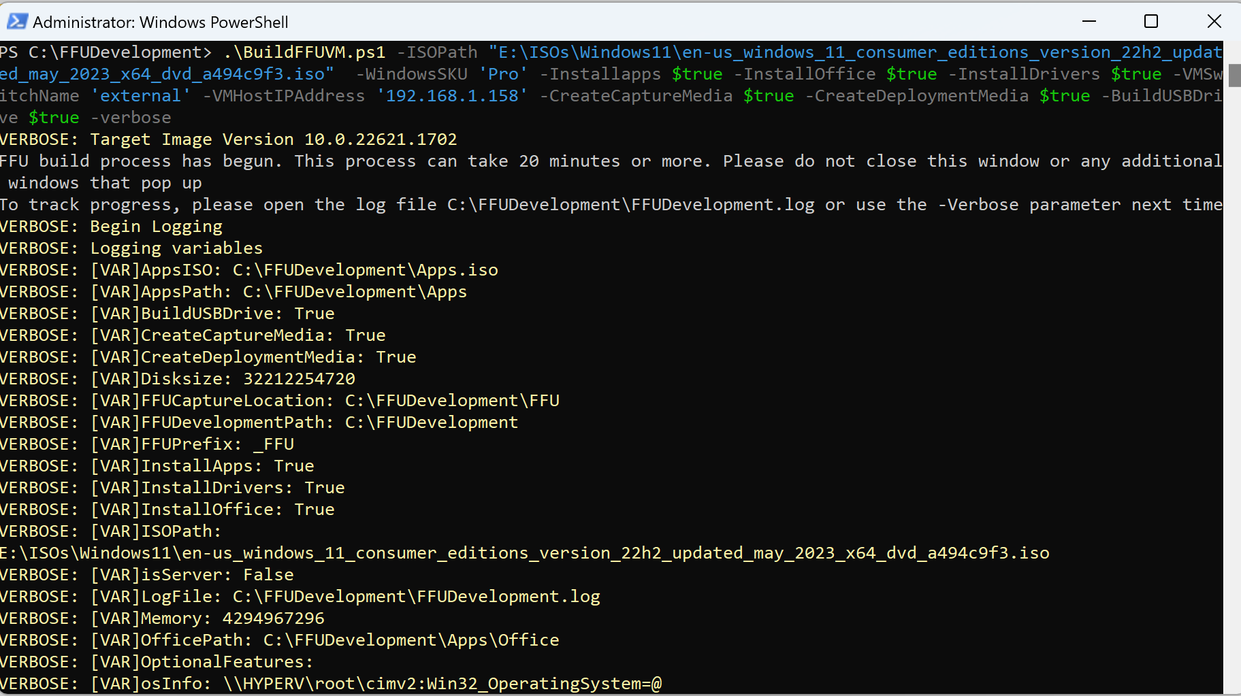
When the script is complete, you should see the following
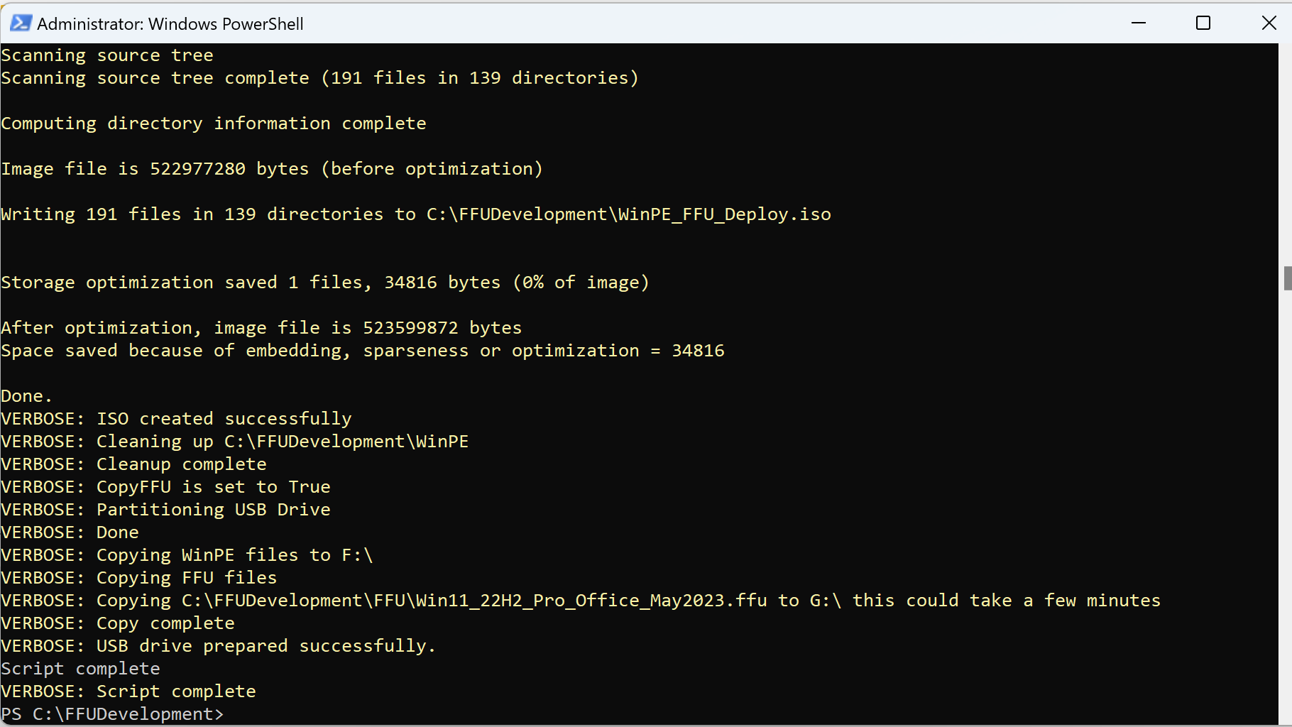
Depending on how fast your machine is, it could take 20 minutes or more for the whole process to complete. Once it’s finished, your USB drive can be used to image a machine. The USB drive should have two partitions: Boot and Deploy. The deploy partition will have the FFU file.
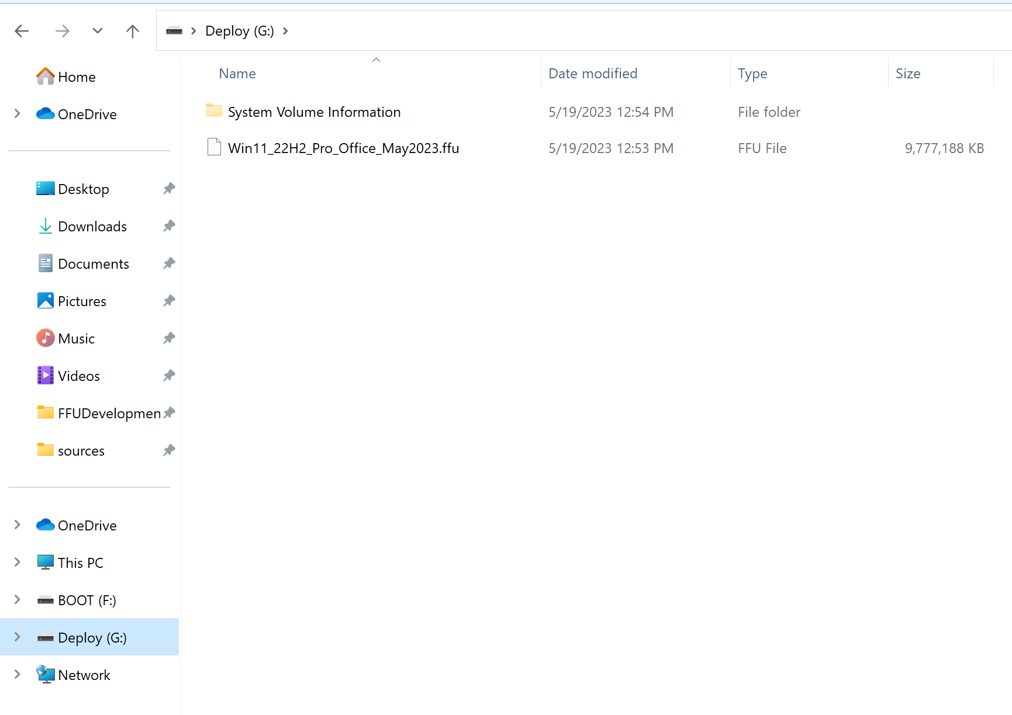

Customizing the USB drive (optional)
The following customizations can be done to your USB drive
- Adding additional drivers
- Device naming
- Adding Provisioning package(s)
- Adding Autopilot for Existing Devices (used for devices not registered to Autopilot)
None of these customizations are required. If you’ve included drivers in your FFU during the building of the FFU, then it’s not necessary to add additional drivers. However, if you didn’t include drivers, you should follow the below process for adding drivers if you plan to use this FFU on multiple models.
The most common customizations are drivers, device naming, and provisioning packages (if not using Autopilot). Naming the device in the FFU process can save you a reboot during Autopilot or using a Provisioning package.

Driver Support (optional but recommended)
Adding drivers is not necessary in most cases, however it will result in a better experience on the device. If you do not add drivers, Windows Update will update the device. The first logged on user will see driver installation pop ups as WU installs the drivers. If IT will be signing on first, they can deal with the driver prompts and validation before delivering to the end user.
If you would like to add drivers, there are two ways to do it.
- Do it during FFU capture setting the -InstallDrivers parameter to $true. This is new as of May 2023.
- Create a drivers folder on your Deploy USB partition and copy your drivers there (e:\drivers\Lenovo 300e) (recommended if managing multiple models and want a single FFU)
The first option will result in faster imaging. This option is good if imaging the same model in an environment many times (hundreds or thousands of devices before the school year starts). It is not recommended to inject drivers of many models in a single FFU. Doing so will increase the driver store considerably. When dealing with devices that have limited storage, you run the risk of running out of disk space. You could create your own FFU per model with only the drivers injected for that specific model.
The second option is easier; however, it will take longer to image. This is due to dism injecting the drivers on the fly. The time it takes will depend on how many drivers are added and the size of the drivers.

Having DISM inject drivers on the fly (recommended if managing multiple models)
Simply create a folder on the deploy partition called drivers. Inside that folder, create sub-folders for each model you will be imaging. If imaging multiple models, a pick list will show up asking which set of drivers to install.
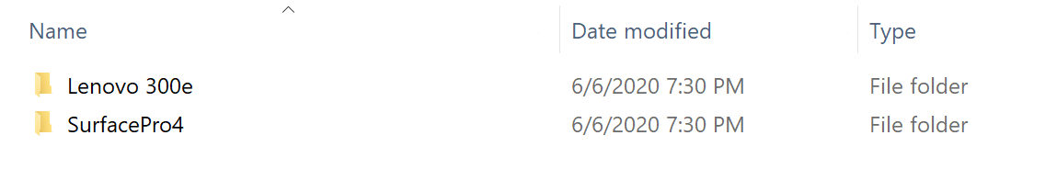

How to inject drivers into FFU
This step is not necessary if you are adding drivers by setting $InstallDrivers to $true when creating your FFU.
If you have a FFU that doesn’t have drivers added and would like to add drivers, you can manually do it with dism.
- If you haven’t already, download the drivers you wish to install for the model you are deploying. Normally, OEMs will provide an enterprise SCCM cab/zip of the drivers. Some, however, do not, especially for the low-cost EDU devices (Lenovo doesn’t for the 14W, 100e, 300e. They require individual downloads for each component, which are all exes). Don’t forget to extract the drivers.
The 3189 driver cab looks like this once extracted
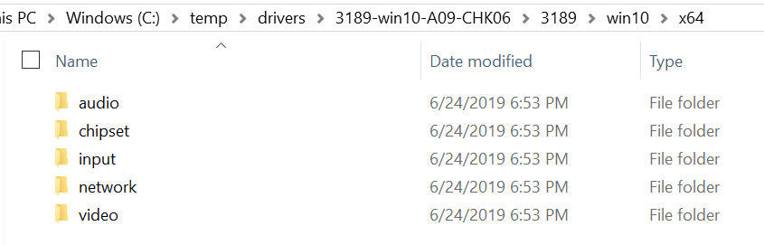

For Lenovo devices, each exe can be extracted via the command line using:
Filename.exe /VERYSILENT /Extract="Yes" /DIR=<PathToWhereYouWantToExtractTo>
- Right-click Start Menu icon and select Windows Powershell (Admin)
- Run mkdir c:\mount
- Run Dism /Mount-Image /ImageFile:"<PathToFFUFile>" /Index:1 /MountDir:"C:\mount"
(where <PathToFFUFile> is the location of your FFU e.g. e:\Win10_1903_Pro_Edu.ffu)
- Run dism /image:C:\mount /Add-Driver /Driver:<PathToDriverFiles> /Recurse
(Replace the c:\temp\drivers with the location of your extracted driver files)
- Run Dism /Unmount-Image /MountDir:C:\mount /commit

Device Naming (optional but recommended)
New as of June 2020
Device naming can be done from PE. The way this works is by leveraging an unattend.xml file to either take input from the user at imaging time or read a list of prefix values and append the serial number of the device. There are some major benefits to doing this:
- Total deployment time is reduced if naming is set at FFU deployment time since there is no additional reboot done during OOBE.
- Reduces the need for multiple provisioning packages or autopilot profiles. This means you can use a single PPKG or autopilot profile.
- Allow for future considerations on how to customize/automate device naming in the future
IMPORTANT – If using a provisioning package or autopilot json file, DO NOT specify a name in either of these. They will overwrite the name you have specified in the unattend.xml.
By leveraging the unattend.xml, you can also add additional steps during the specialize phase to customize the experience even further.

Prompt to enter name
- Create a folder on the deploy partition of the USB drive named unattend
- In the unattend folder, create a file named unattend.xml (this file has already been created if you downloaded this from aka.ms/ffu or the internal Microsoft FFU deployment share . It is in the unattend folder in that location).
- The contents of the unattend.xml file should be the following
<?xml version="1.0" encoding="utf-8"?>
<unattend xmlns="urn:schemas-microsoft-com:unattend">
<settings pass="specialize">
<component name="Microsoft-Windows-Shell-Setup" processorArchitecture="amd64" publicKeyToken="31bf3856ad364e35" language="neutral" versionScope="nonSxS" xmlns:wcm="http://schemas.microsoft.com/WMIConfig/2002/State" xmlns:xsi="http://www.w3.org/2001/XMLSchema-instance">
<ComputerName>MyComputer</ComputerName>
</component>
</settings>
</unattend>
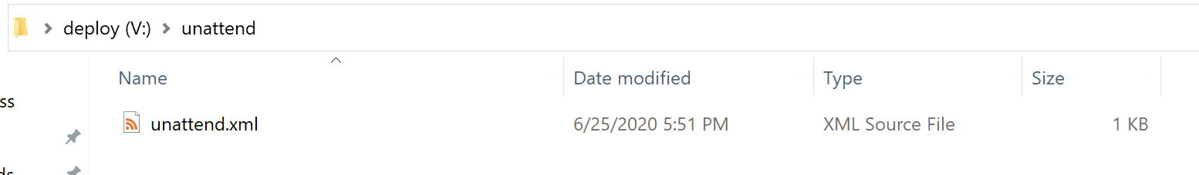
If this file is located during imaging, the user will be prompted to enter a name before the FFU is applied to the device.

Specifying Multiple Name Prefixes
If you have multiple device name prefixes for different locations or device use cases, or even a single prefix, you can specify a prefixes.txt file in the unattend folder. If the prefixes.txt file is detected and a single prefix is listed, the device will just use that prefix and append the serial number of the device. If there are multiple prefixes listed in the prefixes.txt file, you will be prompted to select which prefix you want to name the device and the serial number will be appended to that prefix. If you want a dash in the name, include the dash in the prefix (e.g. if ABCD- is in the prefixes.txt file, the device name will be ABCD-SerialNumber).
- Follow the previous steps used to create the unattend folder and the unattend.xml file.
- Create a file named prefixes.txt in the unattend folder
- In the prefixes.txt file, enter one prefix per line and save the file
Your folder should look like the following
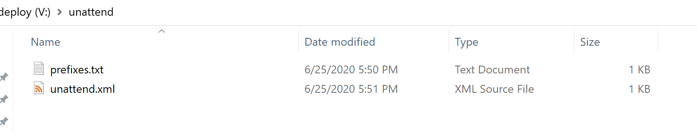
Your prefixes.txt file should look similar to the following image
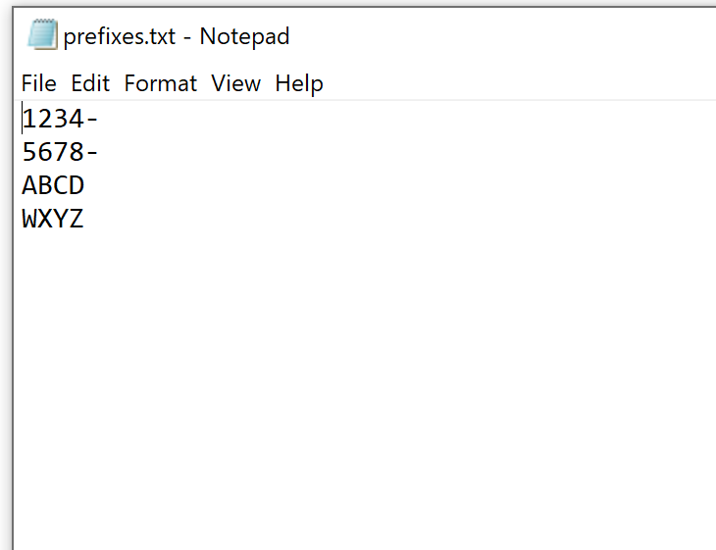

Device Enrollment
There are three common ways to enroll new devices using this method to Azure AD and Intune
- Autopilot
- Provisioning packages
- Autopilot for Existing Devices
If using Autopilot, your devices should already be registered, and an Autopilot profile should be assigned to them. At this point, you can Insert the USB drive to your device and boot from it.
However, if your devices aren’t enrolled into Autopilot, you can either use a Provisioning Package, or Autopilot for Existing devices.
Generally, AP or Provisioning Packages are the two common methods of deployment.
The reasons you may want to use Autopilot for existing devices vs. using Provisioning are:
- Speed of USB drive removal – AP for existing devices allows a technician to remove the USB drive after the device applies the FFU and reboots for the first time. This is because there isn’t a provisioning package. This means you can take the USB drive out sooner and image another device. The FFU usually takes about 2-3 minutes to apply. Once the device reboots after applying the FFU, the drive can be removed if you are not using provisioning packages.
- Setting up a device for 1:1 usage – AP for existing devices will set user device affinity up for the first user that enrolls the device. In this scenario, any applications deployed as available to users/devices in Intune will only show up for that user in the Company Portal. Do not use this if the devices will be shared.
If you’re in a rural location, have poor bandwidth, or are deploying shared devices (laptop carts/labs), provisioning packages are recommended. This guide isn’t designed to go in depth on provisioning packages, but there are ways to include complex apps like contain multiple folders and files. At a high level, you can put all of the content into a WIM file, mount the WIM, and install the apps. We’ll provide a guide on this at a later date.

Optional - Copy provisioning package to the USB drive
Process changed as of June 2020

Recommended for shared devices or devices that may be used 1:1 for now, but could be shared later and won’t be reimaged

If you plan to use a provisioning package to enroll a device, follow the following steps.

- On the deploy partition of your device, create a new folder named PPKG
- Copy one or multiple .PPKG files to the PPKG folder

In June 2020, this process changed to allow for multiple provisioning packages to exist on a single USB drive. If multiple packages are detected, a menu will display each package and ask you to select which package to install. This is useful for organizations that have different packages for different use cases, packages configured for wired vs wireless scenarios, different device names, etc. and do not want to swap packages or have multiple USB drives.

Do NOT place a PPKG file on the BOOT partition of your USB drive AND create a PPKG folder on the deploy partition with one or multiple PPKG files in the folder. This will cause Windows to see two eligible PPKG files to be used during OOBE, which will result in you having to select which package to use at OOBE, slowing the overall process down.

Important – If you set up the device naming method mentioned earlier, make sure to remove the ComputerName (or DNSComputerName) from your provisioning package. If you do not remove the ComputerName (or DNSComputerName) from the package, the package will overwrite the name you specified via the device naming method earlier. The Accounts node in your provisioning package should look like the following image.
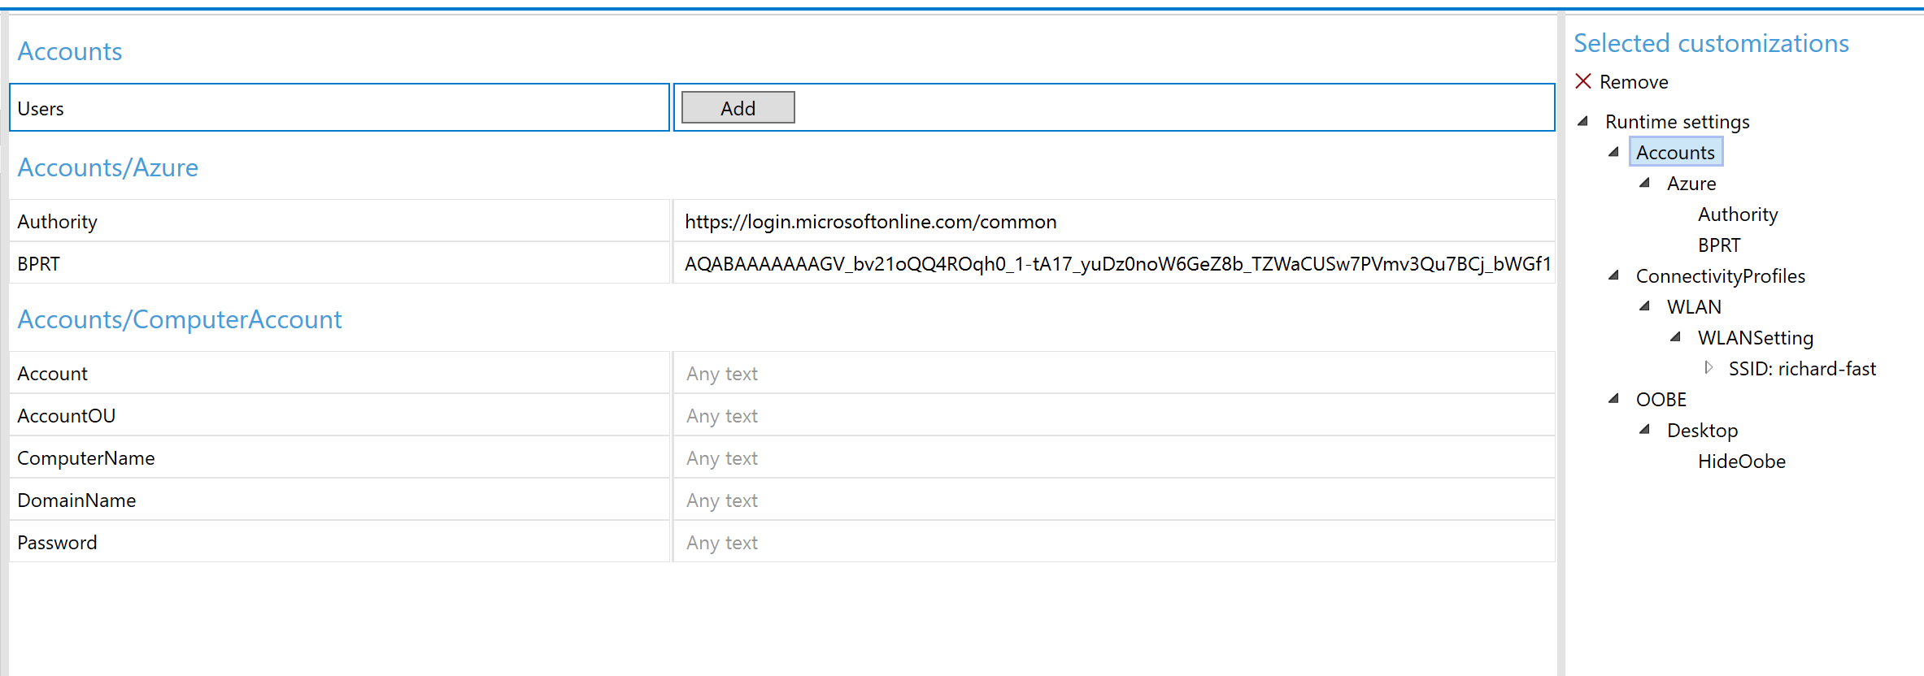

Optional - Using Autopilot for Existing Devices
If you want to configure your media to be able to Autopilot enroll any device, you can use Autopilot for existing devices.
This requires you to create a folder on your Deploy drive called autopilot and insert an AutopilotConfigurationFile.json file in that folder (E:\autopilot\AutopilotConfigurationFile.json). When the device finishes installing the FFU, it will copy the json file to C:\Windows\Provisioning\Autopilot\AutopilotConfigurationFile.json.
Note – AP for existing devices only works for User Driven profiles. It does not work for Self-Deploying or Pre-Provisioning scenarios. It also does not register the device into Autopilot. You can deploy an Autopilot Profile to a group that this device will end up in and select the setting Convert all targeted devices to Autopilot.

Create User Driven Autopilot Profile
Make sure you're using User Driven Profiles (Self Deploying profiles don't work with Offline). In this example, we will query this profile by the display name of the profile. In this case, we'll be using User Driven as the display name.

- In Intune, go to Device Enrollment – Windows Enrollment – Deployment Profiles
- Click Create Profile
- For Name, type in User Driven (the name MUST be User Driven for the powershell command to work later)
- For Convert all targeted devices to Autopilot select Yes
Note – do this in production environments where you want the devices to be autopilot enrolled. This will allow any devices with this profile targeted to go through the Autopilot workflow if the device is reimaged or reset. If you’re working in a lab environment where the devices you use may also be used for demoing provisioning scenarios (SUSPC, WCD) then make sure to set this to NO. You will still get the AP behavior when you use the json file if this is set to No, but the device isn’t really in Autopilot, so it can be used for provisioning and other scenarios later.

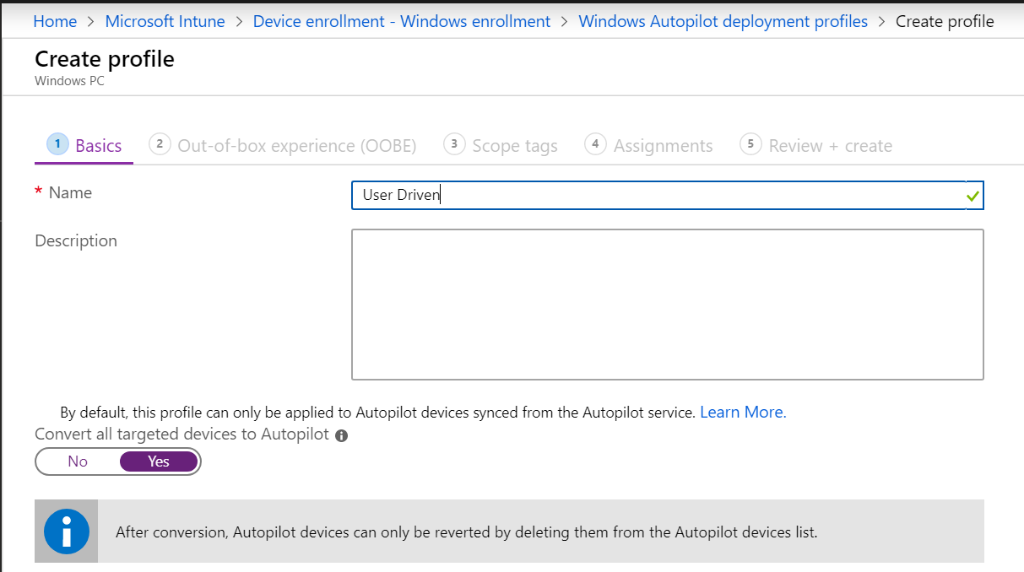

- For OOBE settings, configure like below, making sure to select deployment mode as User-Driven and Join to Azure AD as Azure AD Joined
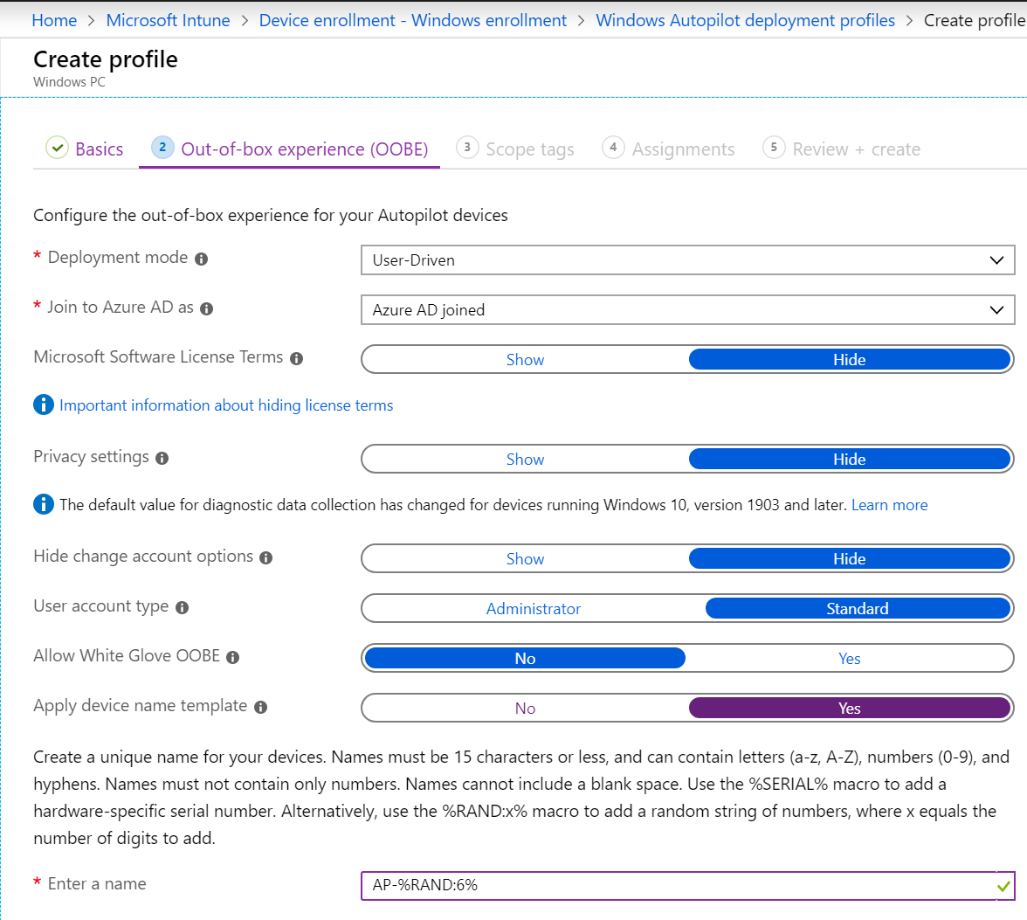
- Click Next through the rest of the wizard (even on the Assignments tab as you do not have to assign this profile to a group). On the Review + create tab, click Create.

Install Azure AD, WindowsAutopilotIntune, Intune Graph Powershell modules
Open Powershell as an admin
Run Install-Module AzureAD
At the untrusted repository message, type Y or A
Run Install-Module WindowsAutopilotIntune
At the untrusted repository message, type Y or A
Run Install-Module Microsoft.Graph.Intune
At the untrusted repository message, type Y or A

Get the User Driven Autopilot profile and convert to JSON
Still in Powershell, run Connect-MSGraph
Type in your credentials
The below command will query for our Autopilot Profile with the display name User Driven. It will then convert the profile to the JSON format and save the file to your desktop as AutoPilotConfigurationFile.json and encode it using ASCII (must be saved as ASCII and it must use this exact name)

Run the following command

Get-AutoPilotProfile |? {$_.displayname -like '*User Driven*'} | ConvertTo-AutoPilotConfigurationJSON | Out-File -FilePath $env:userprofile\desktop\AutoPilotConfigurationFile.json -Encoding ASCII

- Go to your desktop and copy the AutopilotConfigurationFile.json file
- On the Deploy drive of your USB drive, make a folder called autopilot
- Copy the AutopilotConfigurationFile.json file to the autopilot folder
This should look like the following
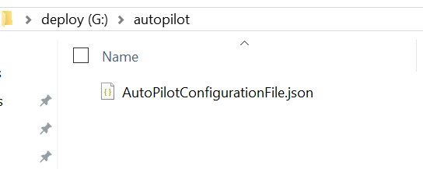

Multiple Autopilot Configuration Files
If imaging many devices that will go to different locations or have different Autopilot settings, you will need multiple Autpilot profiles which means you will also need multiple AutoPilotConfigurationFile.json files.
Give each file a unique name (e.g. ContosoHighSchool.json, FabrakamMiddleSchool.json) and store them in your autopilot folder. If multiple files are detected, you will be prompted for which file you want to use.

Optional - Copying a custom WinRE.wim
If you are deploying a device that does not have built in drivers in Windows, three things need to be updated
- WinPE (Storage and possibly keyboard/mouse drivers)
- Each FFU file (Storage and network drivers)
- WinRE (Storage and possibly keyboard/mouse drivers)
You can create your own custom WinRE.wim file with the appropriate drivers. Keep in mind that the version of WinRE must match the version of Windows you are deploying.
Your Deploy partition should look like the following:
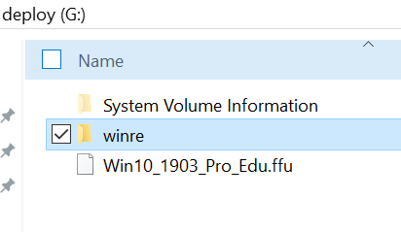
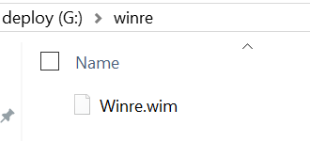

Optional – Adding Multiple Components using unattend.xml
New as of June 2022
In prior releases, only a single component could be used, and it was used primarily to set the device name while in PE to help speed up imaging.
The ApplyFFU.ps1 script has been updated to allow multiple components to be specified in the specialize phase.
In the example below, we’re able to set the device name and run a command to set the date. This can be useful in scenarios where the device date is so old that AzureAD doesn’t allow it to enroll.
See the previous section Device Naming (optional but recommended) for how to configure the USB drive to leverage the unattend.xml file.
<?xml version="1.0" encoding="utf-8"?>
<unattend xmlns="urn:schemas-microsoft-com:unattend">
<settings pass="specialize">
<component name="Microsoft-Windows-Shell-Setup" processorArchitecture="amd64" publicKeyToken="31bf3856ad364e35" language="neutral" versionScope="nonSxS" xmlns:wcm="http://schemas.microsoft.com/WMIConfig/2002/State" xmlns:xsi="http://www.w3.org/2001/XMLSchema-instance">
<ComputerName>A-006259610866</ComputerName>
</component>
<component name="Microsoft-Windows-Deployment" processorArchitecture="amd64" publicKeyToken="31bf3856ad364e35" language="neutral" versionScope="nonSxS" xmlns:wcm="http://schemas.microsoft.com/WMIConfig/2002/State" xmlns:xsi="http://www.w3.org/2001/XMLSchema-instance">
<RunAsynchronous>
<RunAsynchronousCommand wcm:action="add">
<Path>cmd /c date 05-31-2022</Path>
<Order>1</Order>
</RunAsynchronousCommand>
</RunAsynchronous>
</component>
</settings>
</unattend>

Troubleshooting

Deployment
If there are issues, there is a log on the deploy drive that will be created called Scriptlog.txt. That log can be useful in explaining why something failed. Make sure to only have one USB drive plugged into the device and only one hard disk. This process was not tested or validated with multiple USB drives and/or hard disks.

If you have a device that reboots immediately, chances are there aren’t any storage drivers available for that model in WinPE. Most Intel-based devices should work fine as Windows has inbox drivers. AMD may not have available drivers. You likely will need to modify the WinPE media to include drivers for your model. It’s also possible you may not have keyboard drivers.

Creation
If you have issues with creating the FFU, the c:\FFUDevelopment\FFUDevelopment.log file may have some clues.

